The Last Mission
of
The Seventh Cavalry
Book One

by

Charley Brindley

Chapter One

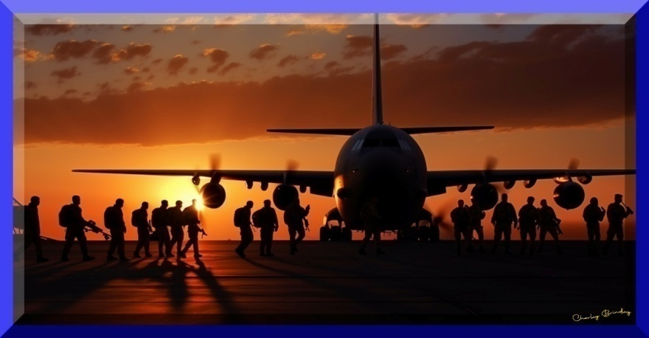

Master Sergeant James Alexander stood at the rear of the C-130, swaying with the movement of the aircraft. He watched his twelve soldiers and wondered how many would survive this mission.
Three quarters? Half?
He knew they were headed for a fight with the Taliban.
God help us. Is that cracked-up drone worth the lives of half my people? Or even one?
He glanced at Captain Sanders, standing beside him, who also watched the soldiers as if he had the same concern.
A light on the forward bulkhead flashed red. The loadmaster saw it and held up his right hand, fingers spread apart. Captain Sanders nodded to the loadmaster.
“All right, Seventh Cavalry! Five minutes to the drop zone,” he told the soldiers. “Mount up, lock and load.”
“Hooyah!” the soldiers yelled as they scrambled to their feet and hooked their static lines to the overhead cable.
“Let’s rock and roll, people!” Sergeant Alexander shouted. “Check your buddy’s straps, packs, and ‘chutes.” He walked between the two rows of soldiers. “Don’t forget to roll when you hit the ground. Break a leg, and we’ll leave you behind to wait for the choppers.” He grabbed Private McAlister’s chest straps, yanking hard, testing the buckles. “Did anyone hear me?” the sergeant yelled.
“Yes, sir!” the soldiers cried out in unison. “Rock and roll when you hit the ground, break a bone, and you’re going home.”
The First Platoon of Delta Company was a newly formed unit that would normally have been led by a first lieutenant. Captain Sanders took charge when Lieutenant Redgrave was relieved on charges of insubordination and audacious behavior, or more accurately, drunk and disorderly while on duty.
Another reason Captain Sanders decided to take command of Delta: Four of the soldiers were women. A recent directive coming from the highest levels of the Pentagon allowed female soldiers to serve in frontline combat.
Every woman in the company had volunteered to fight alongside the men. Sanders had chosen four women who were in top physical condition and had outstanding records in all phases of combat training. These women would be the first in the Seventh Cavalry to face the enemy on the battlefield, and the captain wanted to have firsthand knowledge of their performance in case he had to write a letter to a grieving family.
Hydraulics squealed as the rear door of the aircraft lifted and the tailgate dropped into place. Instantly, the warm air of the cabin was sucked out and replaced by the chill atmosphere of an altitude of five thousand feet.

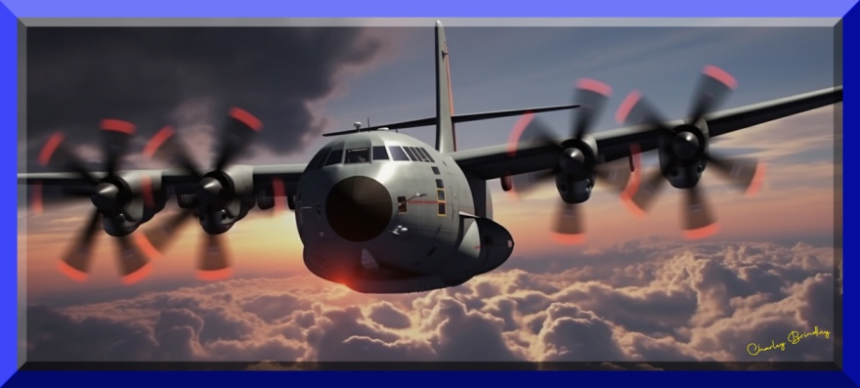

Alexander hurried to the back, where he took hold of a strap on the weapons container to steady himself. He and the captain looked down on heavy cloud cover.
“What d’ya think, Captain?” Alexander asked.
Captain Sanders shrugged and turned to face his soldiers. He tapped the side of his helmet, above his right ear, for a comm check. The noise from the slipstream made it impossible for them to hear him without their communicators. He then spoke into his mic.
“Everyone who can hear me, give me a thumbs-up.”
All but two of the soldiers gave the signal.
Alexander stepped over to the first soldier who didn’t respond. “Paxton, you butt-head.” He flipped on the soldier’s communicator. “The captain’s talking to you.”
“Oh, shit!” Private Paxton said. “Now I’m online, sir.” He gave the captain a thumbs-up.
“Your comm on?” Alexander asked the second soldier.
“Yeah, Sarge,” Private Kady Sharakova said, “but it ain’t working.”
Alexander checked her comm switch. “All right, Sharakova, it’s busted. Just pay attention and do what the guy in front of you does.”
“Right, Sarge. Whose butt we kicking today?”
“All the ugly ones.”
“Cool.”
Scars on a woman’s face usually mark her for scorn or contempt. However, Kady Sharakova wore her disfigurement more as a badge of honor than a blemish of humiliation.
The soldier in front of her grinned and made a floating motion with his hand. “Do everything I do.”
“Oh, grow up, Kawalski.” Kady thumped the front of his helmet with a flick of her index finger.
Alexander hurried back to the tailgate.
The captain spoke into his mic. “We’ve got a layer of clouds below, stretching wall to wall. The pilot said it’s too close to the ground for him to get under, so we’ll have to jump through it.”
“Hooyah,” one of the men said on the comm system.
“You people have had four practice jumps, but this will be the first time The Seventh Cavalry has parachuted into combat. Let’s get it right so I don’t have to requisition body bags.” He looked from one grim face to the next. “The Taliban has managed to bring down one of our newest drone aircraft, the Global Falcon. We’re going to take it away from them and capture the people who figured out how to hack into the drone’s avionics.”
He pulled a folded map from the inside pocket of his camo jacket. Alexander leaned in to watch the captain run his finger along a dashed red line.
“It looks like we’ve got a hike of about ten clicks from the LZ.” The captain handed his map to Alexander as he glanced along the two lines of soldiers. “We’ll be dropping into the edge of the Registan Desert. Our destination is a range of low rocky hills to the north. The electronic beacon on the drone is still working, so we’ll home in on that. There are no trees, no brush, no cover of any kind. As soon as you hit the sand, have your weapons ready. We could drop right into a fight. I’m going out first, followed by the weapons container.” He patted the huge fiberglass box sitting to his right. “Then I want all of you to follow just as fast as if you were lining up for chow at—”
The aircraft jerked violently to the right and tilted into a dive. The captain was thrown hard against the weapons container, knocking him unconscious. He tumbled off the tailgate and into the air as his static line yanked tight.
“We’ve been hit!” one of the soldiers yelled.
The metal of the airframe groaned as the plane twisted to the left, then seemed to right itself for a moment.
Alexander worked his way forward to the door leading into the cockpit. When he pulled the handle, the door flew open, hitting his helmet and almost taking off his arm. He pulled himself into the doorway, leaning into the wind howling through the open door.
“Holy Mother of Satan!” He blinked, not believing what he saw: the whole nose section of the C-130 was gone, including the pilot and co-pilot seats. The navigator’s seat was still in place, but it was empty. When he looked forward through the gaping hole where the front of the plane should have been, he was terrified to see they were spiraling toward a jagged mountaintop, no more than two miles ahead of them.
“Everybody out!” he yelled into his mic. His soldiers stared at him, frozen in place, as if they didn’t understand his order. “Out the back, NOW!”

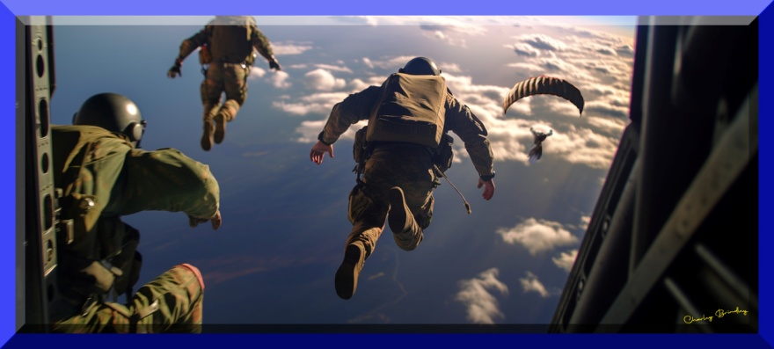

He ran for the back of the plane, deciding he’d better lead them rather than try to push them out. It was like being on one of those crazy floors in a funhouse at the amusement park where sections of the floor undulate up, down, and sideways. It was impossible to keep his balance as the crippled aircraft lurched and shuddered in the air.
As the plane rolled, the metal skin ripped away, screeching through the cabin like a living creature being torn apart. Alexander was thrown against one of the men. A pair of strong hands grabbed his shoulders, keeping him from tumbling to the deck.
At the back of the plane, he knelt to release the latch on one of the straps on the weapons container. When the latch popped loose, he grabbed the second strap, but the buckle was stuck, held tight by the tension. As he struggled with the latch, a hand holding a knife shot past his head and cut the strap. He looked up to see the smiling face of Private Autumn Eaglemoon.
Eaglemoon tapped the side of her helmet, over her right ear. Alexander checked his comm switch; it was off.
“Damn,” he whispered, “the door must’ve hit it.” He flipped it on. “Can anybody hear me?”
Several soldiers responded.
The aircraft jerked to the left, flinging the weapons container out the back. The static line then yanked tight, pulling the ripcords on the container’s two orange chutes.
Alexander signaled his soldiers to follow him as he jumped out, but as soon as he cleared the aircraft, he realized he’d forgotten to connect his static line to the overhead cable. He rolled to his back to see his people streaming out like a family of olive-drab chicks following their mother hen. Their chutes billowed out as they opened one after the other.
God, I hope they all make it.
The right wing of the C-130 tore loose and pinwheeled toward them. Half of it was gone, including the outboard engine. The remaining engine was on fire, leaving a spiraling trail of greasy smoke.

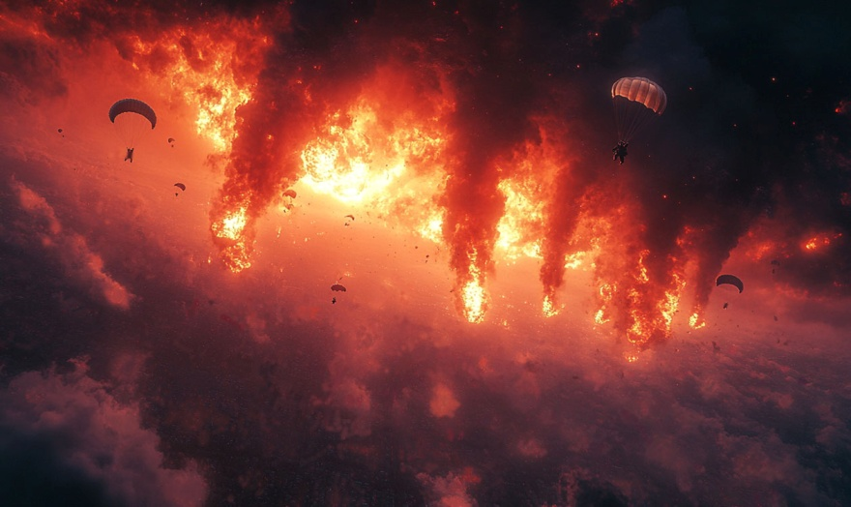

“Holy Fort Jesus!” Alexander watched in horror as the burning wing spiraled toward his troops. “Look out! The wing!”
The soldiers craned their necks, but their billowing canopies blocked their view above. Like a whirling reaper, the wing spun through the air, passing just ten feet beneath one of the soldiers.
“Joaquin!” the soldier yelled into his comm. “Bank right!”
Private Ronald Joaquin pulled his right control line and started a slow-motion turn to his right, but it wasn’t enough. The jagged end of the burning wing caught four of his shroud lines and yanked him sideways with a violent jerk. His chute collapsed and trailed along behind the spinning wing.
“Hit your release buckle!” Alexander yelled into his comm.
“Son-of-a-bitch!” Joaquin yelled.
He flailed at his parachute buckle while being slung around by the spinning wing. Finally, he grabbed the buckle and yanked it open to release the shroud lines tying him to the deadly wing. He fell for ten seconds, then rolled over to be sure he was clear of the wing before releasing his reserve chute. When his reserve chute popped open, he began to breathe again.
“Whew! That was close,” he said.
“Good job, Joaquin,” Alexander said.
He watched the descending wing with the collapsed chute trailing behind as it fell toward the trees below. He then yanked his ripcord and heard a whoosh as the small pilot chute pulled the main parachute from his backpack, then the violent jerk as the main chute opened.
The crippled wing hit the treetops at an angle, slicing through the upper branches, then tumbling to the ground. A wisp of smoke drifted up, then the fuel tank ruptured, sending a cloud of flames and black smoke billowing above the trees.
Alexander scanned the horizon. “That’s strange,” he said as he twisted around, trying to see his soldiers and count the parachutes, but he couldn’t see anything past the canopy of his own chute. “Who’s in the air?” he yelled into his mic. “Sound off by the numbers.”
“Lojab,” he heard in his earpiece.
“Kawalski,” Private Kawalski called out. “There goes the plane, to the southeast.”
The C-130 trailed fire and smoke like a meteor as it careened toward the mountainside. A moment later, it exploded in a ball of fire.
“Holy crap,” Alexander whispered. “All right, by the numbers. I got Lojab and Kawalski.”
He counted the soldiers as they said their names. All the soldiers had an assigned number; Sergeant Alexander was number one, Corporal Lojab was number two, and so on.
More of them called out their names, then there was silence. “Ten?” Alexander said, “Goddamn it!” He yanked his right control line. “Sharakova!” he yelled. “Ransom!” No answer.
“Hey, Sarge,” Kawalski said on the comm.
“Yeah?”
“Sharakova’s comm is still not working, but she got out. She’s right above you.”
“Great. Thanks, Kawalski. Can anybody see Ransom?”
“I’m here, Sarge,” Ransom said. “I think I blacked out for a minute when I hit the side of the plane, but I’m awake now.”
“Good. Counting me, that makes thirteen,” Alexander said. “Everyone’s in the air.”
“I saw three crewmen from the C-130 get out of the plane,” Kawalski said. “They popped their chutes right below me.”
“What happened to the captain?” Lojab asked.
“Captain Sanders,” Alexander said into his mic. He waited a moment. “Captain Sanders, can you hear me?”
There was no response.
“Hey, Sarge,” someone said on the comm. “I thought we were jumping through clouds?”
Alexander stared at the ground—the layer of clouds was gone.
That’s what was strange; no clouds.
“And the desert?” another asked.
Below them was nothing but green in every direction.
“That don’t look like no desert I ever saw.”
“Check out that river to the northeast.”
“Damn, that thing is huge.”
“This looks more like India or Pakistan to me.”
“I don’t know what that pilot was smoking, but he sure didn’t take us to the Registan Desert.”
“Cut the chatter,” Sergeant Alexander said. They were now below fifteen hundred feet. “Anyone see the weapons container?”
“Nothing,” Ledbetter said. “I don’t see it anywhere.”
“No,” Paxton said. “Those orange chutes should show up like you white boys in the ghetto, but I don’t see ‘em.”
None of the others saw any sign of the weapons container.
“Okay,” Alexander said. “Steer for that clearing just to the southwest, at ten o’clock.”
“Got it, Sarge.”
“We’re right behind you.”
“Listen up, people,” Sergeant Alexander said. “As soon as you hit the ground, pop your chute and grab your banger.”
“Ooo, I love it when he talks dirty.”
“Can it, Kawalski,” he said. “I’m sure somebody saw us, so be ready for anything.”
All the soldiers glided into the clearing and landed without mishap. The three remaining crewmen from the aircraft dropped in behind them.
“Squad One,” Alexander ordered, “set up a perimeter.”
“Roger that.”
“Archibald Ledbetter,” he said, “you and Kawalski go climb that tall oak and set up a lookout, and get some weapons to the three crewmen.”
“Right, Sarge.” Ledbetter and Kawalski ran toward the C-130 crewmen.
“All quiet on the eastern side,” Paxton said.
“Same here,” Joaquin said from the other side of the clearing.
“All right,” Alexander said. “Stay on your toes. Whoever shot us down is bound to come after us. Let’s get out of this clearing. We’re sitting ducks out here.”
“Hey, Sarge,” Kawalski whispered into his mic. “You got two peeps coming at you, double-time.” He and Ledbetter were halfway up the oak tree.
“Where?”
“On your six.”
Sergeant Alexander spun around. “This is it,” he said into his mic as he watched for the two people. “Everybody get out of sight and ready your weapons.”
“I don’t think they’re armed,” Kawalski whispered.
“Quiet.”
Alexander heard the people coming toward him through the brush. He pressed himself back against a pine tree and cocked the hammer on his Sig automatic.
A moment later, they ran past him. It was a man and woman, unarmed except for a wooden pitchfork carried by the woman. Their clothing was nothing more than short, ragged tunics, and they were barefoot.
“Not Taliban,” Paxton whispered over the comm.
“Too white.”
“Too what?”
“Too white for Pacs or Indians.”
“They’re still going, Sarge,” Kawalski said from his perch in the tree. “They’re jumping over logs and boulders, running like hell.”
“Well,” Sarge said, “they definitely weren’t coming after us.”
“They didn’t even know we were here.”
“Another one,” Kawalski said.
“What?”
“There’s another one coming. Same direction. Looks like a kid.”
“Get out of sight,” Sarge whispered.
The kid, a boy of about ten, ran past. He was pale white and wore the same type of short tunic as the others. He, too, was barefoot.
“More,” Kawalski said. “Looks like a whole family. Moving slower, pulling an animal of some kind.”
“Goat,” Ledbetter said from his position in the tree beside Kawalski.
“A goat?” Alexander asked.
“Yup.”
Alexander stepped out in front of the first person in the group—a teenage girl—and held out his arm to stop her. The girl screamed and ran back the way she’d come, then veered away, running in another direction. A woman in the group saw Alexander and turned to run after the girl. When the man came along with his goat, Alexander pointed his Sig pistol at his chest.
“Hold it right there.”
The man gasped, dropped the rope, and hurried away as fast as he could. The goat bleated and tried to nip Alexander’s sleeve.
The last person, a little girl, gave Alexander a curious look but then picked up the end of the rope and pulled the goat away, in the direction her father had gone.
“Weird,” Alexander whispered.
“Yeah,” someone said on the comm. “Too weird.”
“Did you see their eyes?” Lojab asked.
“Yes,” Private Karina Balentine said. “Except for the little girl, they were terrified.”
“Of us?”
“No,” Alexander said. “They were running from something else, and I couldn’t stop them. I might as well be a cigar store Indian.”
“A tobacconist’s carved Native American image,” Private Lorelei Fusilier said.
“What?”
“You can’t say ‘Indian’ anymore.”
“Well, shit. How about ‘numbskull?’” Alexander said. “Does that offend any race, creed, or religion?”
“Creed and religion are the same thing.”
“No, they’re not,” Karina Balentine said. “Creed is a set of beliefs, and religion is the worship of deities.”
“Actually, we prefer ‘cranially challenged’ to ‘numbskull.’”
“You’re personality-challenged, Paxton.”
“Will you people shut the fuck up!” Alexander yelled. “I feel like a goddamned kindergarten teacher.”
“Early childhood instructor.”
“Mentor of diminutive peeps.”
“Jesus Christ!” Alexander said.
“Now I’m offended.”
“More coming,” Kawalski said. “A bunch, and you better get out of the way. They’re in a hurry.”
Thirty people hurried past Alexander and the others. They were all dressed the same way; simple short tunics and no shoes. Their clothing was ragged and made of a gray, coarsely-woven cloth. A few of the people pulled oxen and goats along behind them. Some carried crude farm tools, and one woman carried an earthen pot filled with wooden kitchen utensils.
Alexander stepped out to grab an old man by the arm. “Who are you people, and what’s the hurry?”
The old man yelled and tried to pull away, but Alexander held tight.
“Don’t be afraid. We won’t hurt you.”
But the man was afraid; in fact, he was terrified. He kept glancing back over his shoulder, jabbering some words.
“What the hell language is that?” Alexander asked.
“Nothing I ever heard,” Lojab said as he cradled his M16 rifle and stood beside Alexander.
“Me either,” Joaquin said from the other side of Alexander.
The old man looked from one face to the next. He was obviously frightened by these strangers, but much more afraid of something behind him.
Several more people ran past, then the old man jerked his arm free and pulled his ox along, trying to get away.
“You want me to stop him, Sarge?” Lojab asked.
“No, let him get out of here before he has a heart attack.”
“His words were definitely not the Pashtun language.”
“Not Arabic either.”
“Or Urdu.”
“Urdu?”
“That’s what the Pacs speak,” Sharakova said. “And English. If they were Pakistani, they probably would have understood your English, Sarge.”
“Yeah.” Alexander watched the last of the people disappear along the trail. “That’s what I thought. And they’re too fair-skinned to be Pakistani.”
“Uh-oh,” Kawalski said.
“Now what?” Alexander asked.
“Elephants.”
“We’re definitely in India.”
“I doubt we were that far off course,” Alexander said.
“Well,” Kawalski said, “you might ask those two chick peeps where we are.”
“What two chicks?”
“On top of the elephants.”

